# ABI-Electronic Tag

This feature is located in the Teacher Data Table. The site will determine the correct code.

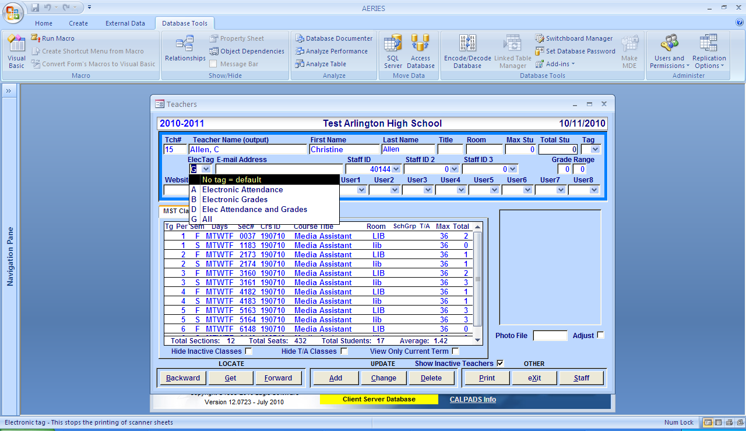

When a teacher is i*nactivated*, be sure to remove the Electronic Attendance tag